UNIT – 2 Assemblers -1

Assemblers -1: Basic Assembler Function - A Simple SIC Assembler, Assembler Algorithm and Data Structures, Machine Dependent Assembler Features - Instruction Formats & Addressing Modes, Program Relocation.
2.1 Basic Assembler Functions:

The basic assembler functions are:

  - Translating mnemonic operation codes to their machine language equivalents
  - Assigning machine addresses to symbolic labels

Assembler’s functions

- Convert mnemonic operation codes to their machine language equivalents

- Convert symbolic operands to their equivalent machine addresses

- Build the machine instructions in the proper format

- Convert the data constants to internal machine representations

- Write the object program and the assembly listing

Assembler directives
These directives do not have object code conversion but gives direction to the assembler to perform some function.
- Not translated into machine instructions
- Providing information to the assembler
Basic assembler directives
- START – Specify name and starting address for the program;
Ex- SUM START 1000 [ Name of the program is SUM, and starting address of the program is 1000]
- END – Indicate the end of the source program and(optionally) specify the first executable instruction in the program;
Ex- END FIRST [where FIRST is the label name of the first executable statement in the program]
- BYTE – Generate character or hexadecimal constant, occupying as many bytes as needed to represent the constant;
Ex- 1. MEM BYTE C’SYSTEM SOFTWARE’ [ generate the character constants and occupying 15 bytes of memory location
2. INPUTDEV BYTE X’05’[ generate hexadecimal constant 05 – occupies 1 bye of memory location]
- WORD – Generate one-word integer constant;
Ex- ALPHA WORD 05
- RESB – Reserve the indicated number of bytes for a data area
Ex- ALPHA RESB 10
- RESW – Reserve the indicated number of words for a data area
Ex- ALPHA RESW 10

The assembler design can be done:
- Single pass assembler
- Multi-pass assembler

Single-pass Assembler:

In this case the whole process of scanning, parsing, and object code conversion is done in single pass. The only problem with this method is resolving forward reference. This is shown with an example below:

10 1000 FIRST STL RETADR 141033

-------------
-------------
-------------
---------------
95 1033 RETADR RESW 1

[Forward reference: reference to a label that is defined later in the program]

In the above example in line number 10 the instruction STL will store the linkage register with the contents of RETADR. But during the processing of this instruction the value of this symbol is not known as it is defined at the line number 95. Since in single-pass assembler the scanning, parsing and object code conversion happens simultaneously. The instruction is fetched; it is scanned for tokens, parsed for syntax and semantic validity. If it valid then it has to be converted to its equivalent object code. For this the object code is generated for the opcode STL and the value for the symbol RETADR need to be added, which is not available. Due to this reason usually the design is done in two passes. So a multi-pass assembler resolves the forward references and then converts into the object code. Hence the process of the multi-pass assembler can be as follows:

Functions of Pass-1
- Assign addresses to all the statements
- Save the addresses assigned to all labels to be used in Pass-2
- Perform some processing of assembler directives such as RESW, RESB to find the length of data areas for assigning the address values.
- Defines the symbols in the symbol table(generate the symbol table)

Functions of pass-2
- Assemble the instructions (translating operation codes and looking up addresses).
- Generate data values defined by BYTE, WORD etc.
- Perform the processing of the assembler directives not done during pass-1.
- Write the object program and assembler listing.

Algorithms and Data structure

The simple assembler uses two major internal data structures: the operation Code Table (OPTAB) and the Symbol Table (SYMTAB). Along with that LOCCTR variable is used which helps in the assignment of the addresses.

Internal data structures
- Operation Code Table (OPTAB)
- Symbol Table (SYMTAB)
- Location Counter(LOCCTR)

OPTAB:
- It is used to lookup mnemonic operation codes and translates them to their machine language equivalents. In most of the assembler the opcode table also contains information about instruction format and length.

- In pass 1 the OPTAB is used to look up and validate the operation code in the source program. In pass 2, it is used to translate the operation codes to machine language. In simple SIC machine this process can be performed in either in pass 1 or in pass 2. But for machine like SIC/XE that has instructions of different lengths, we must search OPTAB in the first pass to find the instruction length for incrementing LOCCTR.
- In pass 2 we take the information from OPTAB to tell us which instruction format to use in assembling the instruction, and any peculiarities of the object code instruction.

- OPTAB is usually organized as a hash table, with mnemonic operation code as the key. The hash table organization is particularly appropriate, since it provides fast retrieval with a minimum of searching. Most of the cases the OPTAB is a static table- that is, entries are not normally added to or deleted from it.

SYMTAB:

- This table includes the name and value for each label in the source program, together with flags to indicate the error conditions (e.g., if a symbol is defined in two different places).
- During Pass 1: labels are entered into the symbol table along with their assigned address value as they are encountered. All the symbols address value should get resolved at the pass 1.
- During Pass 2: Symbols used as operands are looked up the symbol table to obtain the address value to be inserted in the assembled instructions.
- SYMTAB is usually organized as a hash table for efficiency of insertion and retrieval. Since entries are rarely deleted, efficiency of deletion is the important criteria for optimization.

- Both pass 1 and pass 2 require reading the source program. Apart from this an intermediate file is created by pass 1 that contains each source statement together with its assigned address, error indicators, etc. This file is one of the inputs to the pass 2.
- A copy of the source program is also an input to the pass 2, which is used to retain the operations that may be performed during pass 1 (such as scanning the operation field for symbols and addressing flags), so that these need not be performed during pass 2. Similarly, pointers into OPTAB and SYMTAB is retained for each operation code and symbol used. This avoids need to repeat many of the table-searching operations.

LOCCTR:

Apart from the SYMTAB and OPTAB, this is another important variable which helps in the assignment of the addresses. LOCCTR is initialized to the beginning address mentioned in the START statement of the program. After each statement is processed, the length of the assembled instruction is added to the LOCCTR to make it point to the next instruction. Whenever a label is encountered in an instruction the LOCCTR value gives the address to be associated with that label.
Updating of LOCCTR

If opcode=’WORD’ then
LOCCTR <- LOCCTR+3
If opcode=’RESW’ then
LOCCTR <- LOCCTR+3*#(operand)
If opcode=’BYTE’ then
Find the length of constants in bytes
LOCCTR <- LOCCTR+length in bytes
If opcode=’RESB’ then
LOCCTR <- LOCCTR+#(operand)
If opcode is OPTAB
Check the types of instructions format and then
Update LOCCTR by its length in bytes(1B,2B,3B,4B)

The Algorithm for Pass 1:
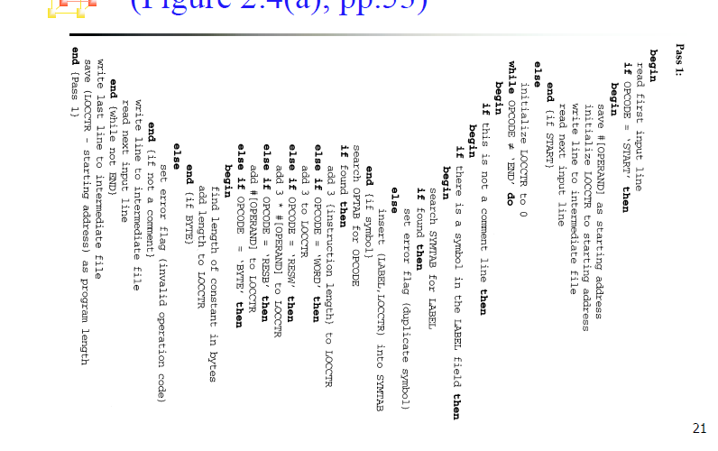

- The algorithm scans the first statement START and saves the operand field (the address) as the starting address of the program. Initializes the LOCCTR value to this address. This line is written to the intermediate line.
- If no operand is mentioned the LOCCTR is initialized to zero. If a label is encountered, the symbol has to be entered in the symbol table along with its associated address value.
- If the symbol already exists that indicates an entry of the same symbol already exists. So an error flag is set indicating a duplication of the symbol.

- It next checks for the mnemonic code, it searches for this code in the OPTAB. If found then the length of the instruction is added to the LOCCTR to make it point to the next instruction.
- If the opcode is the directive WORD it adds a value 3 to the LOCCTR. If it is RESW, it needs to add the number of data word to the LOCCTR. If it is BYTE it adds a value one to the LOCCTR, if RESB it adds number of bytes.
- If it is END directive then it is the end of the program it finds the length of the program by evaluating current LOCCTR – the starting address mentioned in the operand field of the END directive. Each processed line is written to the intermediate file.

The Algorithm for Pass 2:
- Here the first input line is read from the intermediate file. If the opcode is START, then this line is directly written to the list file. A header record is written in the object program which gives the starting address and the length of the program (which is calculated during pass 1). Then the first text record is initialized. Comment lines are ignored. In the instruction, for the opcode the OPTAB is searched to find the object code.
- If a symbol is there in the operand field, the symbol table is searched to get the address value for this which gets added to the object code of the opcode. If the address not found then zero value is stored as operands address. An error flag is set indicating it as undefined. If symbol itself is not found then store 0 as operand address and the object code instruction is assembled.
- If the opcode is BYTE or WORD, then the constant value is converted to its equivalent object code( for example, for character EOF, its equivalent hexadecimal value ‘454f46’ is stored). If the object code cannot fit into the current text record, a new text record is created and the rest of the instructions object code is listed. The text records are written to the object program. Once the whole program is assemble and when the END directive is encountered, the End record is written.

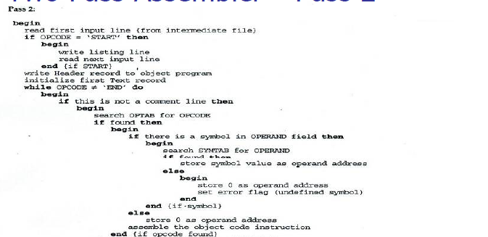
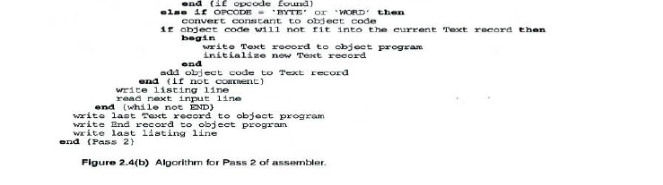

The assembled program will be loaded into memory for execution. The simple object program contains three types of records: Header record, Text record and end record. The header record contains the starting address and length. Text record contains the translated instructions and data of the program, together with an indication of the addresses where these are to be loaded. The end record marks the end of the object program and specifies the address where the execution is to begin.
Header record:
Col 1 H
Col. 2-7 Program name
Col 8-13 Starting address of object program (hexadecimal)
Col 14-19 Length of object program in bytes (hexadecimal)
Text record:
Col. 1 T
Col 2-7. Starting address for object code in this record (hexadecimal)
Col 8-9 Length off object code in this record in bytes (hexadecimal)
Col 10-69 Object code, represented in hexadecimal (2 columns per byte of
object code)
End record:
Col. 1 E
Col 2-7 Address of first executable instruction in object program
(hexadecimal)

Assembler Design: simple SIC

Object program
Machine-Dependent Assembler Features: - SIC/XE

- Instruction formats
- addressing modes
- Program relocation.

The instruction formats depend on the memory organization and the size of the memory. In SIC machine the memory is byte addressable. Word size is 3 bytes. So the size of the memory is 2¹² bytes. Accordingly it supports only one instruction format. It has only two registers: register A and Index register. Therefore the addressing modes supported by this architecture are direct, indirect, and indexed. Whereas the memory of a SIC/XE machine is 2²⁰ bytes (1 MB). This supports four different types of instruction types, they are:
- 1 byte instruction
- 2 byte instruction
- 3 byte instruction
- 4 byte instruction

Instructions can be:
– Instructions involving register to register
– Instructions with one operand in memory, the other in Accumulator (Single operand instruction)
– Extended instruction format

• Addressing Modes are:

– Index Addressing(SIC): Opcode m, x
– Indirect Addressing: Opcode @m
– PC-relative: Opcode m
– Base relative: Opcode m
– Immediate addressing: Opcode #c

1. Translations for the Instruction involving Register-Register addressing mode:
During pass 1 the registers can be entered as part of the symbol table itself. The value for these registers is their equivalent numeric codes. During pass2, these values are assembled along with the mnemonics object code. If required a separate table can be created with the register names and their equivalent numeric values.

2. Translation involving Register-Memory instructions:

In SIC/XE machine there are four instruction formats and five addressing modes. For formats and addressing modes Among the instruction formats, format -3 and format-4 instructions are Register-Memory type of instruction. One of the operand is always in a register and the other operand is in the memory. The addressing mode tells us the way in which the operand from the memory is to be fetched.
There are two ways: Program-counter relative and Base-relative. This addressing mode can be represented by either using format-3 type or format-4 type of instruction format. In format-3, the instruction has the opcode followed by a 12-bit displacement value in the address field. Where as in format-4 the instruction contains the mnemonic code followed by a 20-bit displacement value in the address field.
Program-Counter Relative:

In this usually format-3 instruction format is used. The instruction contains the opcode followed by a 12-bit displacement value.
The range of displacement values are from 0 -2048. This displacement (should be small enough to fit in a 12-bit field) value is added to the current contents of the program counter to get the target address of the operand required by the instruction. This is relative way of calculating the address of the operand relative to the program counter. Hence the displacement of the operand is relative to the current program counter value. The following example shows how the address is calculated:
Base-Relative Addressing Mode:
In this mode the base register is used to mention the displacement value. Therefore the target address is
TA = (base) + displacement value
- This addressing mode is used when the range of displacement value is not sufficient. Hence the operand is not relative to the instruction as in PC-relative addressing mode. Whenever this mode is used it is indicated by using a directive BASE.
- The moment the assembler encounters this directive the next instruction uses base-relative addressing mode to calculate the target address of the operand.
- When NOBASE directive is used then it indicates the base register is no more used to calculate the target address of the operand. Assembler first chooses PC-relative, when the displacement field is not enough it uses Base-relative.

LDB #LENGTH (instruction)
BASE LENGTH (directive)

For example:
12 0003 LDB #LENGTH 69202D
13 BASE LENGTH
: :
100 0033 LENGTH RESW 1
105 0036 BUFFER RESB 4096
: :
160 104E STCH BUFFER, X 57C003
165 1051 TIXR T B850

In the above example the use of directive BASE indicates that Base-relative addressing mode is to be used to calculate the target address of below instruction

160 104E STCH BUFFER, X 57C003

PC-relative is no longer used. The value of the LENGTH is stored in the base register. If PC-relative is used then the target address calculated is:

Disp = TA – (PC) = 0036 –1051 = EFE5

PC relative is no longer applicable, so we try to use BASE relative addressing mode.

- The LDB instruction loads the value of length in the base register which 0033. BASE directive explicitly tells the assembler that it has the value of LENGTH.

BUFFER is at location (0036)16

Immediate Addressing Mode
In this mode no memory reference is involved. If immediate mode is used the target address is the operand itself.

If the symbol is referred in the instruction as the immediate operand then it is immediate with PC-relative mode as shown in the example below
Indirect and PC-relative mode:
In this type of instruction the symbol used in the instruction is the address of the location which contains the address of the operand. The address of this is found using PC-relative addressing mode. For example:
The instruction jumps the control to the address location RETADR which in turn has the address of the operand. If address of RETADR is 0030, the target address is then 0003 as calculated above.

Program Relocation
Sometimes it is required to load and run several programs at the same time. The system must be able to load these programs wherever there is place in the memory. Therefore the exact starting is not known until the load time.
55 101B +LDA THREE 00102D

- This statement says that the register A is loaded with the value stored at location 102D. Suppose it is decided to load and execute the program at location 2000 instead of location 1000.

- Then at address 102D the required value which needs to be loaded in the register A is no more available. The address also gets changed relative to the displacement of the program. Hence we need to make some changes in the address portion of the instruction so that we can load and execute the program at location 2000.
- Apart from the instruction which will undergo a change in their operand address value as the program load address changes. There exist some parts in the program which will remain same regardless of where the program is being loaded.

- Since assembler will not know actual location where the program will get loaded, it cannot make the necessary changes in the addresses used in the program. However, the assembler identifies for the loader those parts of the program which need modification.
- An object program that has the information necessary to perform this kind of modification is called the relocatable program.

- The above diagram shows the concept of relocation. Initially the program is loaded at location 0000. The instruction JSUB is loaded at location 0006.
- The address field of this instruction contains 01036, which is the address of the instruction labeled RDREC. The second figure shows that if the program is to be loaded at new location 5000.
- The address of the instruction JSUB gets modified to new location 6036. Likewise the third figure shows that if the program is relocated at location 7420, the JSUB instruction would need to be changed to 4B108456 that correspond to the new address of RDREC.
- The only part of the program that require modification at load time are those that specify direct addresses. The rest of the instructions need not be modified. The instructions which doesn’t require modification are the ones that is not a memory address (immediate addressing) and PC-relative, Base-relative instructions.
- From the object program, it is not possible to distinguish the address and constant The assembler must keep some information to tell the loader. The object program that contains the modification record is called a relocatable program.
- For an address label, its address is assigned relative to the start of the program (START 0). The assembler produces a Modification record to store the starting location and the length of the address field to be modified. The command for the loader must also be a part of the object program. The Modification has the following format

Modification record
Col. 1 M
Col. 2-7 Starting location of the address field to be modified, relative to the
beginning of the program (Hex)
Col. 8-9 Length of the address field to be modified, in half-bytes (Hex)
One modification record is created for each address to be modified The length is stored in half-bytes (4 bits) The starting location is the location of the byte containing the leftmost bits of the address field to be modified. If the field contains an odd number of half-bytes, the starting location begins in the middle of the first byte.

In the above object code the red boxes indicate the addresses that need modifications. The object code lines at the end are the descriptions of the modification records for those instructions which need change if relocation occurs. M00000705 is the modification suggested for the statement at location 0007 and requires modification 5-half bytes. Similarly the remaining instructions indicate.

